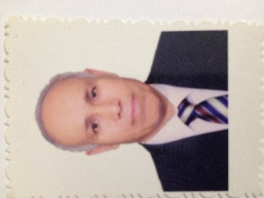
Eng. Mahmoud Eltayeb
ARAC Former Chair
ILAV&IAF&APAC&AFRAC&ARAC Peer Evaluator TL

